**Possible title options:**

“Correlating the infrared CO stretch signal on Au to active sites”

“Spectroelectrochemical investigation of active site blocking with Pb UPD on Au”

“Site blocking on Au with Pb under potential deposition – an ATR-SEIRAS study”

**Abstract:**

In this paper we show that the CO stretch signal as observed with attenuated total reflection surface enhanced IR absorption spectroscopy (ATR-SEIRAS) is correlated with stepped facets rather than the (111)-like terraces. (211) and (110)-like facets were previously shown to be the active sites for the CO2 to CO reduction reaction on Au. We combine the ATR-SEIRAS with Pb UPD to observe the CO stretch signal as sites are blocked and revealed again. We support our findings with the use of DFT calculations.

**Introduction:**

Au is the most selective single metal catalyst for the electrochemical reduction of CO2 to CO. Pb UPD can be used to selectively and sequentially block sites on Au. The shape of the UPD curve can be used as a fingerprint of the crystal identity in the case of single crystals. In the case of polycrystalline surfaces a convolution of deposition on various sites is observed. During Pb deposition, a broad wave corresponding to deposition on stepped surfaces and defects is initially observed. At more negative potentials and higher Pb coverage, a sharper peak related to (111) type sites is observed. It has previously been shown that (110) and (211)-like sites are active for the reduction of CO2 to CO [A]. ATR-SEIRAS studies tracking the CO stretch band have previously been performed on polycrystalline Au in relation to the CO2 reduction reaction [E, F, G, H]. Here we track the UPD process by simultaneously measuring the CO stretch frequency with ATR-SEIRAS.

**Results/Discussion:**

Figures 1a and b show the ATR-SEIRAS spectra of the Au SEIRAS film in CO saturated 0.1 M HClO4 electrolyte before and after addition of Pb. When Pb is present, the signal corresponding to CO adsorbed on Au is not present towards lower potentials but reappears as the potential is made more positive again. The phenomenon is clarified by integrating the CO stretch signal and plotting it against the applied potential as shown in Figure 1c. Without Pb, the CO stretch signal is seen to be present in the entire potential range and with a maximum in integrated intensity around ca. 0.2 V vs SHE. The positive going scan largely tracks the negative going scan. With Pb present, the signal intensity drops over an approximately 100 mV range from ca. 0.25 to 0.15 V vs SHE. The signal reversibly reappears over the same potential range on the positive going scan. The corresponding CVs are shown in Figure 1d. Without Pb, the oxidation of CO is seen anodically and HER cathodically. With Pb, a UPD curve is observed. Slight offsets from zero in the CVs are attributed to small amounts of oxygen leading to oxygen evolution.

The Pb UPD has been overlaid with the transient in the signal in Figure 2. The UPD curve is in good agreement with previous reports on polycrystalline Au [B]. The sharp waves around -0.05 V correspond to (111) terrace type sites whereas the broad waves between 0.05 and 0.25 correspond to a convolution of more open surfaces such as (100), (110) and (211). The transient in the SEIRAS CO signal is clearly seen to correspond to the UPD on the stepped and defect rich sites.

Using DFT, the theoretical effect of the presence of Pb upon the adsorption of CO on different facets of Au was investigated. *More discussion based on theoretical work…*

A conceptually similar approach has been reported for Cu deposition on Au surfaces [C]. As an infrared active probe molecule, the authors made use of absorption bands of coadsorbing sulfate ions rather than the CO stretch bands as shown here.

Conclusion:

Pb UPD on polycrystalline Au was combined with ATR-SEIRAS to perform controlled blocking of surface sites while observing the CO stretch band. The CO stretch band was seen to disappear concurrently with the deposition of Pb on defect and step sites. The effect was corroborated through the use of DFT simulations showing that XXXX…

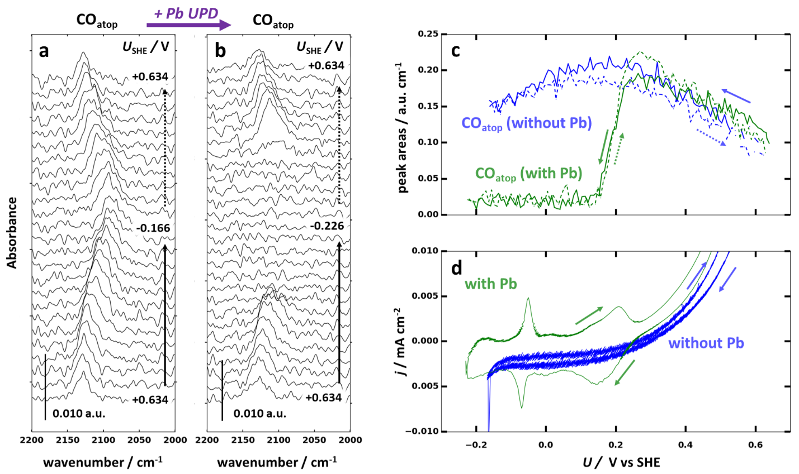

Figure 1: ATR-SEIRAS on Au SEIRAS film in the CO stretch region in 0.1 M HClO4. a) SEIRAS spectra before addition of Pb. b) SEIRAS spectra with 1 mM Pb(ClO4)2. Every 8th spectrum is shown. c) Integrated intensities of the CO stretch peak as a function of potential. d) Corresponding 2 mV/s CV with and without Pb.

**Supporting Information:**

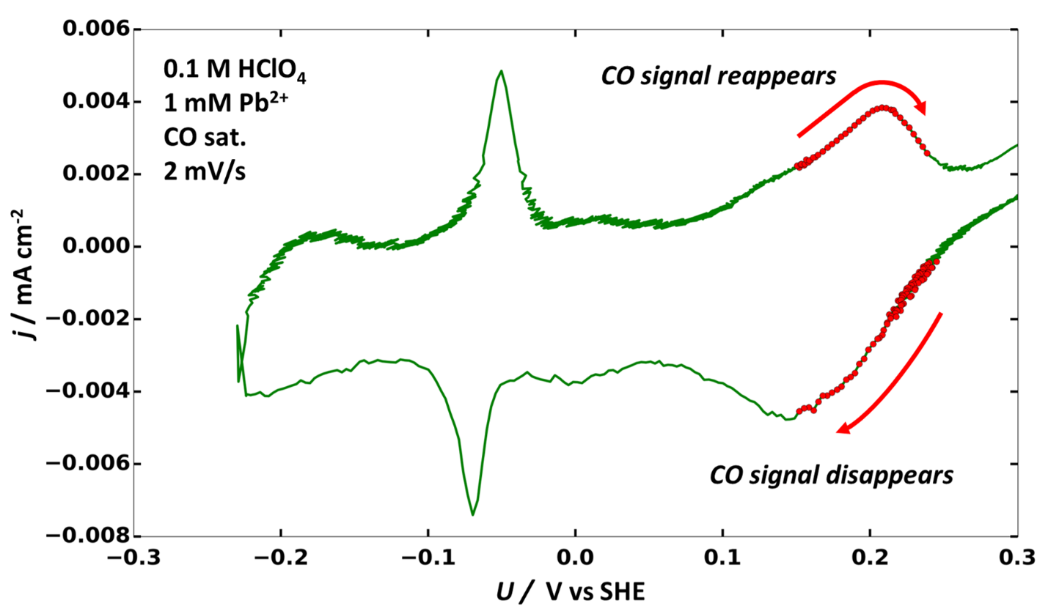

Figure : Pb UPD curve on Au SEIRAS film. The regions corresponding to the loss and gain of the SEIRAS CO stretch signal have been overlaid.

**Experimental:**

Setup:  
ATR-SEIRAS measurements were performed using an INVENIO-R (Bruker) spectrometer equipped with a liquid nitrogen cooled MCT detector. The ATR configuration was obtained by placing a variable angle ATR accessory, VeeMAXIII (PIKE Technologies) in the beam path. The spectroelectrochemical cell was a two compartment cell machined from PTFE where the two compartments were separated by a proton exchange membrane (Nafion 117). Au mesh was used as the counter electrode and a mecury-mercurous sulfate reference electrode was connected through a Luggin capillary. The working electrode was comprised of a nanostructured Au thin film on a Si internal reflection element. The working compartment was purged continuously with either Ar or CO. 32 interferrograms were combined to yield an absorbance spectrum every 4 seconds.

Film preparation:  
The Au thin film was prepared through electroless deposition following previous reports with some modifications [D]. The Si hemisphere was polished sequentially with 0.3 and 0.05 µm alumina (Buehler) and subsequently sonicated in milli-Q water, ethanol and milli-Q water for 10 min each. The Si surface was hydrogen terminated with 40 % NH4F for 2 min and then rinsed with milli-Q water. The Au deposition solution was prepared from three stock solutions; A: 0.03 M NaAuClO4, B: 0.3 M Na2SO3 + 0.1 M Na2S2O3 + 0.1 M NH4Cl, and C: 2 % HF. 1 mL of solution A was diluted with 2 mL of milli-Q water in a polypropylene container and subsequently 1 mL of solution B was added yielding a clear, colourless solution. Finally, 2 mL of solution C were added yielding the plating solution. The crystal was placed in a heating bath set to 60 °C. 0.7 mL of plating solution was drop cast onto the heated crystal face (20 mm diameter) and left for 5 min resulting in a vibrant Au coloured film. The plating solution was removed from the surface with a pipette and exchanged for room temperature milli-Q water several times to quench the plating reaction. The resulting film had a resistance of 9-12 Ohm across the diagonal. This procedure was found to yield maximum CO absorption signals ranging from ca. 0.008 to 0.02 A.U. (absorbance units) in 0.1 HClO4 and ca. 1 bar CO, depending on the specific film.

Initial film cycling:  
The working compartment of the assembled cell was filled with 0.1 M HClO4 and closed with the lid. After purging the solution with Ar for 10 min, the film was cycled at 50 mV/s between initial oxygen evolution and hydrogen evolution in order to clean and structure the film.

ATR-SEIRAS measurements:

A spectral background was taken at +0.634 V vs SHE (0 V vs the reference, Hg/Hg2SO4) in Ar saturated electrolyte and then gas composition was changed to CO. A 2 mV/s CV was performed while obtaining IR spectra. Pb2+ was subsequently added in the form of Pb(ClO4)2 to yield a 1 mM Pb2+ concentration in the cell. IR spectra were continuously acquired while cycling the potential in the Pb UPD region.

DFT calculations:

XXX XXX XXX.

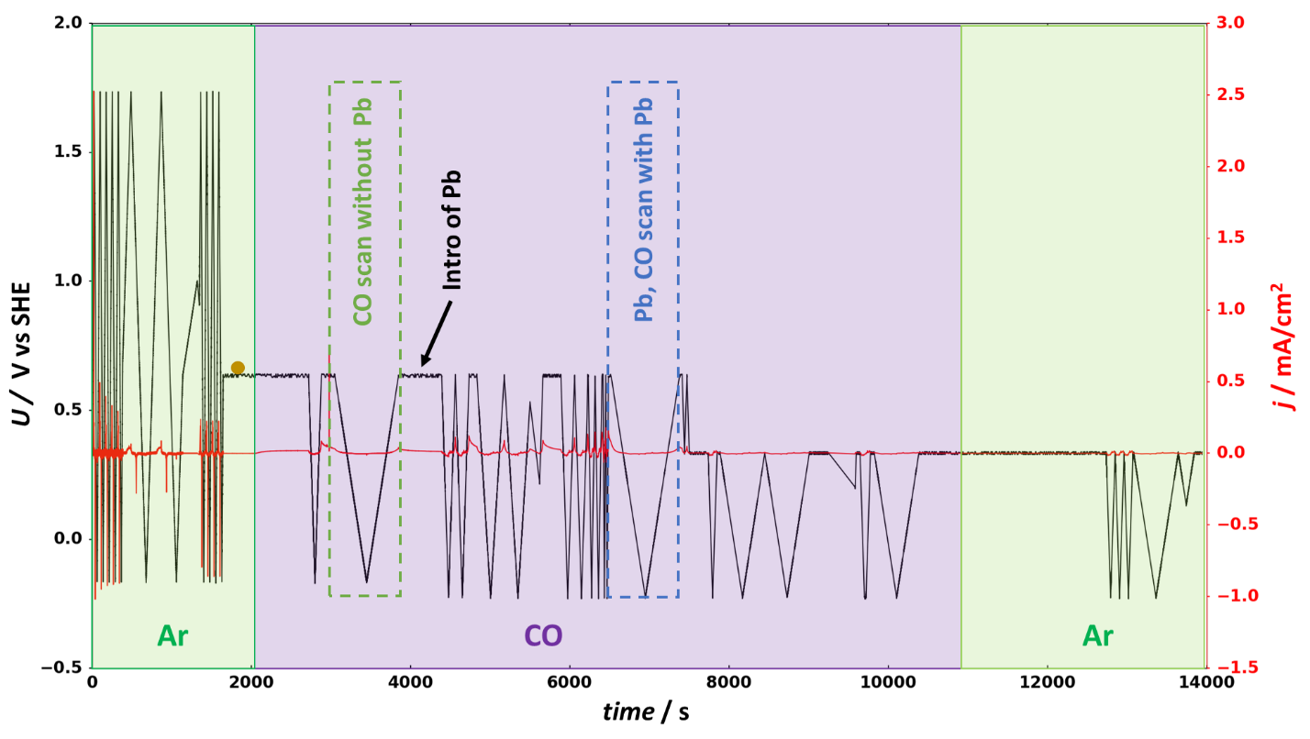

Figure S1: Electrochemical program for Pb UPD on Au SEIRAS film. Regions with Ar or Co saturated electrolyte are indicated as well as the introduction of Pb. 2 mV/s CVs with and without Pb corresponding to the data shown in Figure 1 are indicated by stippled boxes.

**References:**

[A] S. Mezzavilla, S. Horch, I. E. L. Stephens, B. Seger, and I. Chorkendorff.

Structure Sensitivity in the Electrocatalytic Reduction of CO2 with Gold

Catalysts. Angewandte Chemie, 131(12):3814–3818, 2019.

[B] K. Engelsmann, W. Lorenz, and E. Schmidt. Underpotential deposition of

lead on polycrystalline and single-crystal gold surfaces: Part I. Thermodynamics.

Journal of Electroanalytical Chemistry and Interfacial Electrochemistry,

114(1):1–10, 1980.

[C] K. Ataka, G. Nishina, W. B. Cai, S. G. Sun, and M. Osawa. Dynamics of the

dissolution of an underpotentially deposited Cu layer on Au(111): A combined

time-resolved surface-enhanced infrared and chronoamperometric

study. Electrochemistry Communications, 2(6):417–421, 2000.

[D] H. Miyake, S. Ye, and M. Osawa. Electroless deposition of gold thin films

on silicon for surface-enhanced infrared spectroelectrochemistry. Electrochemistry

Communications, 4(12):973–977, 2002.

[E] A. Wuttig, M. Yaguchi, K. Motobayashi, M. Osawa, and Y. Surendranath.

Inhibited proton transfer enhances Au-catalyzed CO2-to-fuels selectivity.

Proceedings of the National Academy of Sciences of the United States of America,

113(32):E4585–E4593, 2016.

[F] A. Wuttig, J. Ryu, and Y. Surendranath. Electrolyte Competition Controls

Surface Binding of CO Intermediates to CO2 Reduction Catalysts. ChemRxiv,

2019.

[G] M. Dunwell, Q. Lu, Q. Lu, J. M. Heyes, J. Rosen, J. G. Chen, Y. Yan, F. Jiao,

and B. Xu. The Central Role of Bicarbonate in the Electrochemical Reduction

of Carbon Dioxide on Gold. Journal of the American Chemical Society, 139(10):

3774–3783, 2017.

[H] M. Dunwell, X. Yang, B. P. Setzler, J. Anibal, Y. Yan, and B. Xu. Examination

of Near-Electrode Concentration Gradients and Kinetic Impacts on

the Electrochemical Reduction of CO2 using Surface-Enhanced Infrared

Spectroscopy. ACS Catalysis, 8(5):3999–4008, 2018.

**Comments:**

Additional introduction required?

More references in general.

Experimental section in SI if only a communication.

What journal to apply to? (i.e. how many words and figures?) ACS energy letters communication again?

How about authors?

T. Hogg, S. Vijay, H. H. Kristoffersen, J C Ehlers, Y. Katayama, Y. Shao-Horn, K. Chan, J Nørskov, B. Seger, I. Chorkendorff.